

***Universidad Tecnológica Nacional - Facultad Regional Buenos Aires***

**Sintaxis y Semántica de los Lenguajes**

**2018**

**Trabajo Práctico Grupal N°3**

**Tema:** Enteros

**Curso:** K2003

**Profesor:** Oscar Bruno

**Fecha de Entrega:** 25/4

**Grupo N°**

|  |  |
| --- | --- |
| **Alumno** | **Legajo** |
| CICERCHIA, Mauro | 163.394-6 |
| PESCE, Macarena | 163.782-4 |
| SAINATO, Agustín | 163.673-0 |
| VENTURA, Nicolás | 163.436-7 |

**Autómata**

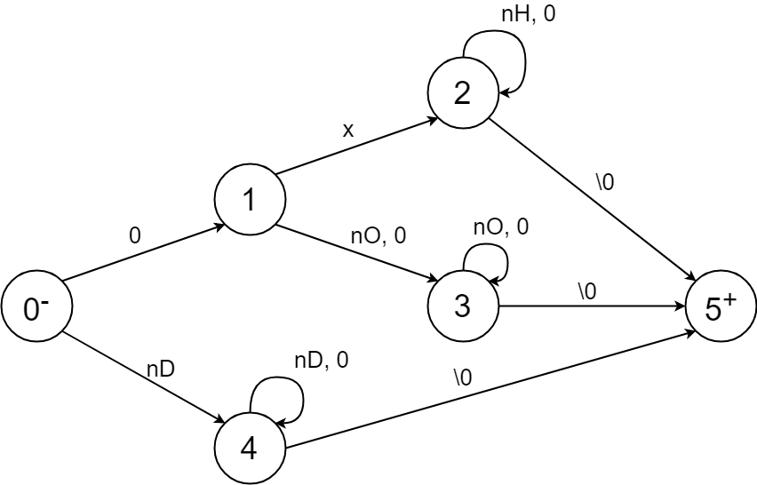

**Tabla de Transiciones**

|  |  |  |  |  |  |  |  |
| --- | --- | --- | --- | --- | --- | --- | --- |
|  | 0 | x | nD | nO | nH | \0 | otro |
| 0- | 1 | 6 | 4 | 6 | 6 | 6 | 6 |
| 1 | 3 | 2 | 6 | 3 | 6 | 6 | 6 |
| 2 | 2 | 6 | 6 | 6 | 2 | 5 | 6 |
| 3 | 3 | 6 | 6 | 3 | 6 | 5 | 6 |
| 4 | 4 | 6 | 4 | 6 | 6 | 5 | 6 |
| 5+ | 6 | 6 | 6 | 6 | 6 | 6 | 6 |
| 6err | 6 | 6 | 6 | 6 | 6 | 6 | 6 |

**Código**

